Data Aggregation and Analysis of Sales Department Attrition in Human Resources

- Create 2 tables. The first table shows how many salespeople have attrition. Store this information in a column called “attrition”. The second table counts how many salespeople have no attrition. Store this information in a column called “Non Attrition”.
USE hr_analysis;

CREATE TABLE attrition_count AS
SELECT COUNT(*) AS attrition
FROM employee_sales
WHERE Department = 'Sales' AND Attrition = 'Yes';
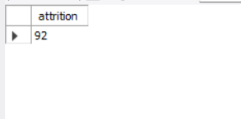

CREATE TABLE non_attrition_count AS
SELECT COUNT(*) AS `Non Attrition`
FROM employee_sales
WHERE Department = 'Sales' AND Attrition = 'No';

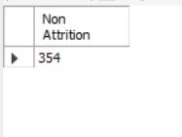
2) Create 3 statistics tables (average, min, max) showing the monthly income for: all salespeople, those with attrition and those without attrition. For each table, label the columns “average_monthly_income”, “min_monthly_income”, and “max_monthly_income”.

USE hr_analysis;

CREATE TABLE sales_all_stats AS
SELECT
AVG(MonthlyIncome) AS average_monthly_income,
MIN(MonthlyIncome) AS min_monthly_income,
MAX(MonthlyIncome) AS max_monthly_income
FROM employee_sales
WHERE Department = 'Sales';

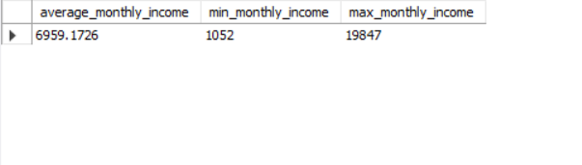
CREATE TABLE sales_attrition_stats AS
SELECT
AVG(MonthlyIncome) AS average_monthly_income,
MIN(MonthlyIncome) AS min_monthly_income,
MAX(MonthlyIncome) AS max_monthly_income
FROM employee_sales
WHERE Department = 'Sales' AND Attrition = 'Yes';

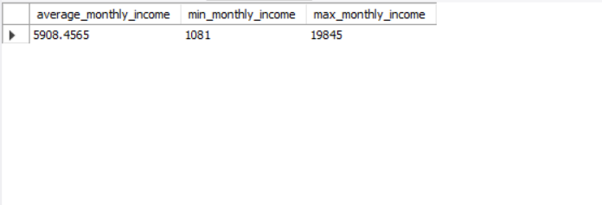
CREATE TABLE sales_non_attrition_stats AS
SELECT
AVG(MonthlyIncome) AS average_monthly_income,
MIN(MonthlyIncome) AS min_monthly_income,
MAX(MonthlyIncome) AS max_monthly_income
FROM employee_sales
WHERE Department = 'Sales' AND Attrition = 'No';

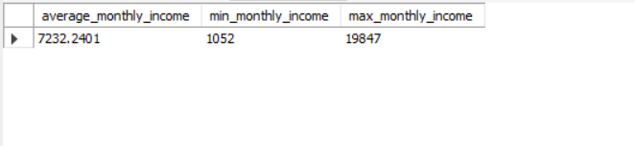

- Create 2 tables containing the monthly income and count of salespeople making that monthly income for: salespeople with attrition and salespeople without attrition. Label the columns as: “monthlyincome” and “count”

-- Salespeople WITH attrition
CREATE TABLE income_attrition_dist AS
SELECT
MonthlyIncome AS monthlyincome,
COUNT(*) AS `count`
FROM employee_sales
WHERE Department = 'Sales' AND Attrition = 'Yes'
GROUP BY MonthlyIncome
ORDER BY MonthlyIncome;
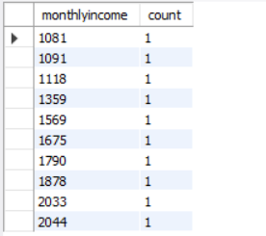
-- Salespeople WITHOUT attrition
CREATE TABLE income_non_attrition_dist AS
SELECT
MonthlyIncome AS monthlyincome,
COUNT(*) AS `count`
FROM employee_sales
WHERE Department = 'Sales' AND Attrition = 'No'
GROUP BY MonthlyIncome
ORDER BY MonthlyIncome;
